How to Move VMs (VirtualBox) from One Location to Another

1. Shut down VirtualBox, back up your <userdoc>\.VirtualBox\VirtualBox.xml file

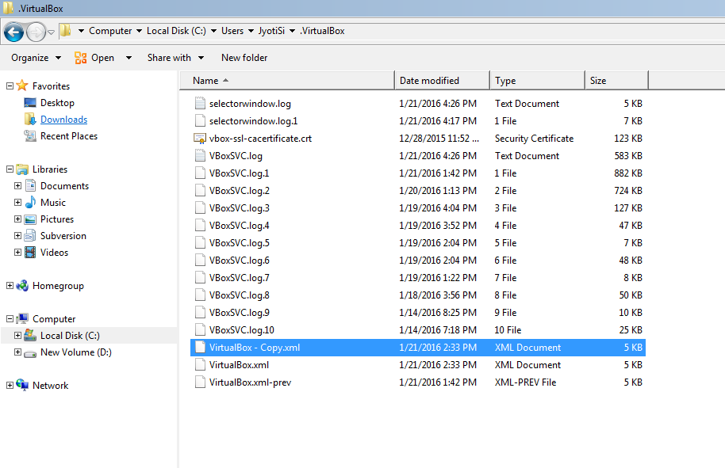

1. Find your existing "Virtualbox VMs" folder, and *copy* (not move) the whole folder with contents to your new drive D:

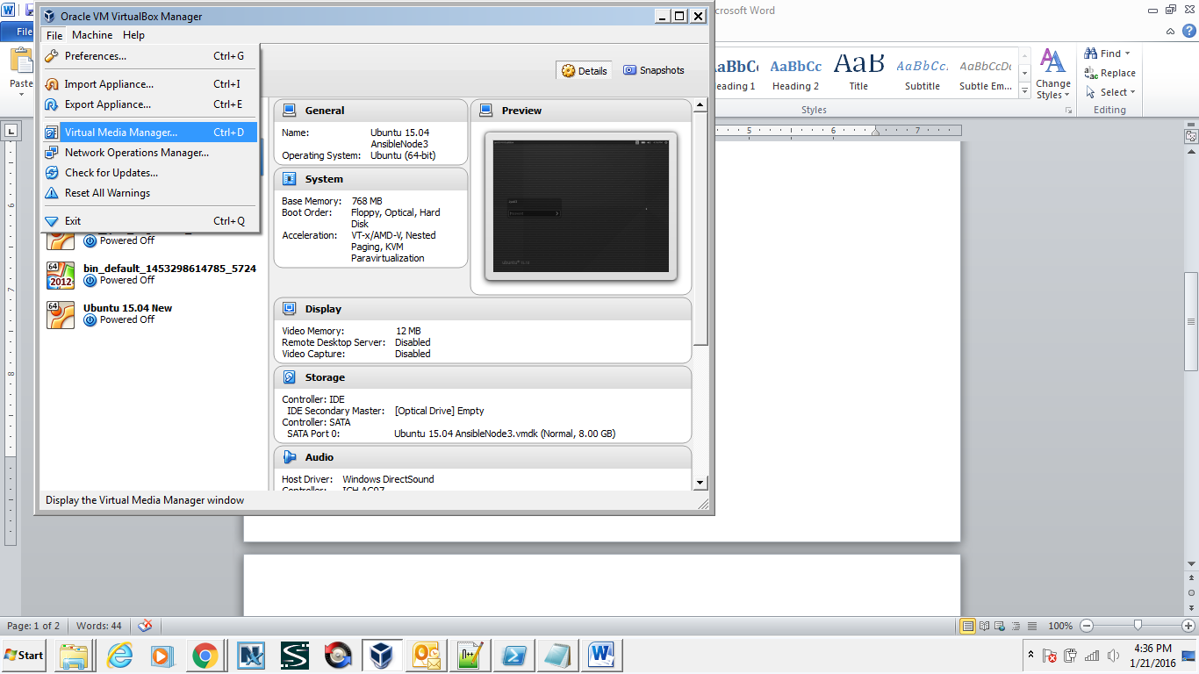

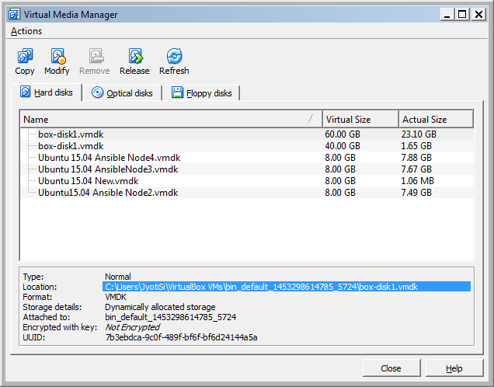

1. Run VirtualBox, then *for each VM in turn* :-
   1. Right click the VM name and select "Remove" from the popup menu. Answer no to the "physically delete files?" question.
   2. Select the *Machine|Add..* menu item, navigate to the VMs new location on drive E:, and select the .vbox file.
   3. Repeat for any remaining VMs.
2. In *File|Preferences*, set the default machine path to new path on D drive "D:\VirtualBox\VirtualBox VMs"
3. Test each of the VMs. Only after you are sure they all work, delete the old VM containing folder, i.e. delete "C:\VirtualBox VMs".

*Ref:* [*https://forums.virtualbox.org/viewtopic.php?f=1&t=48258*](https://forums.virtualbox.org/viewtopic.php?f=1&t=48258) (scroll down almost 2/3rd of page)